DEEP LEARNING
Unit – 1
1.Supervised and Unsupervised learning
Supervised and unsupervised learning are two main types of machine learning. In supervised learning, the model is trained with labeled data where each input has a corresponding output. On the other hand, unsupervised learning involves training the model with unlabeled data which helps to uncover patterns, structures or relationships within the data without predefined outputs. In this article we will see Supervised and unsupervised learning in more details.

What is Supervised learning?
Supervised learning as the name suggests, works like a teacher or supervisor guiding the machine. In this approach we teach or train the machine using the labelled data(correct answers or classifications) which means each input has the correct output in the form of answer or category attached to it. After that machine is provided with a new set of examples (data) so that it can analyses the training data and produces a correct outcome from labeled data.
For example, a labeled dataset of images of Elephant, Camel and Cow would have each image tagged with either "Elephant", "Camel" or "Cow."
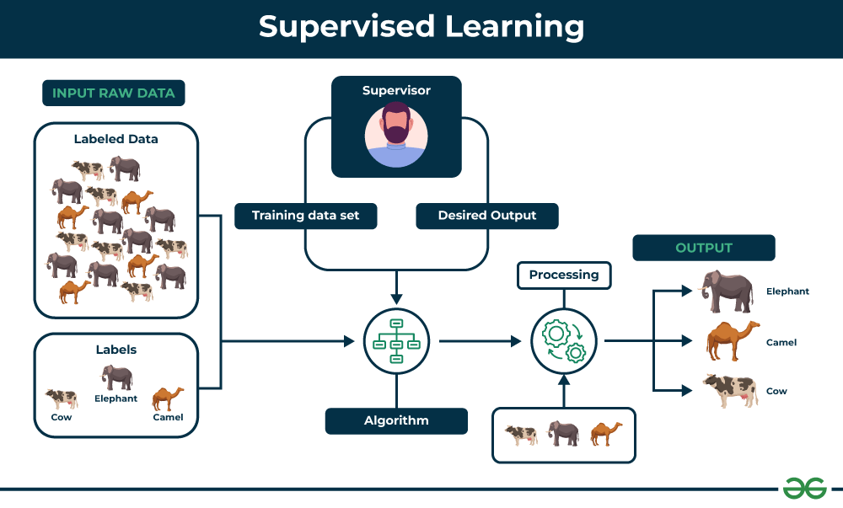
Example to Understand
Imagine we have a basket full of different fruits that we want the machine to identify. The machine first looks at the image of a fruit and extracts features like its shape, color and texture. Then it compares these features to the fruits it has already learned during training. If the new fruit’s features closely match those of an apple, the machine will predict that the fruit is an apple.
For example, suppose we train the machine by showing it fruits one by one:
- If the fruit is round, has a small depression at the top and is red, it is labeled as an Apple.
- If the fruit is long, curved and greenish-yellow, it is labeled as a Banana.
Now after this training, if we give the machine a new fruit (say a banana) from the basket and ask it to identify it, the machine will use what it has learned during training. It will analyze the shape and color of the new fruit and classify it as a Banana placing it in the correct category. In this way, the machine learns from the training data (the basket with labeled fruits) and applies that knowledge to recognize new, unseen fruits.
Types of Supervised Learning
Supervised learning is classified into two types of algorithms:
1. Regression
A regression is used to predict continuous values such as house prices, stock prices or temperature. Regression algorithms learn how to connect input data to a specific number or value.
Some common regression algorithms include:
- Linear Regression
- Polynomial Regression
- Lasso Regression
- Ridge Regression
2. Classification
A classification is used to predict categorical values such as whether a customer will buy or not, whether an email is spam or not or whether a medical image shows a tumor or not. Classification algorithms learn how to connect input data to the probability of belonging to different groups or categories.
Some of the most common classification algorithms include:
- Logistic Regression
- Support Vector Machines
- Decision Trees
- Random Forests
- Naive Baye
Applications of Supervised learning
It can be used to solve variety of problems which includes:
- Image classification: It can automatically classify images into different categories such as animals, objects or scenes helps in the tasks like image search, content moderation and image-based product recommendations.
- Medical diagnosis: It can assist in medical diagnosis by analyzing patient data such as medical images, test results and patient history to identify patterns that suggest specific diseases or conditions.
- Fraud detection: They can analyze financial transactions and identify patterns that shows fraudulent activity which helps financial institutions prevent fraud and protect their customers.
- Natural language processing (NLP): It plays a important role in NLP tasks including sentiment analysis, machine translation and text summarization which enables machines to understand and process human language effectively.
Advantages of Supervised learning
- It learns from labeled examples to make accurate predictions on new, unseen data.
- With more data and training, these models increases their accuracy which leads to better performance and more reliable predictions.
- It works well for many tasks from detecting spam emails to predicting house prices as it has the ability to handle various computational challenges.
- It can handle both classification (sorting data into categories) and regression (predicting numbers) which makes it flexible for different problems.
Disadvantages of Supervised learning
- It requires a well-labeled dataset where each input has a corresponding output. Creating such datasets takes a lot of time, money and effort and can sometimes have mistakes, this makes supervised learning hard to use.
- It works well on many tasks but can struggle with very complex or unstructured problems like understanding patterns or abstract ideas that doesn't relate to what it was trained on.
- These models can sometimes overfit the training data which means they perform well on training data but poor on new, unseen data.
- These models often need constant updating with new labeled data to stay accurate as real-world data changes over time.
What is Unsupervised learning?
Unsupervised learning is a part of machine learning which works differently from supervised because there is no teacher(supervisor) involved to guide the machine. In this approach the machine is given with data that has no labels or categories. It analyzes the data on its own to find patterns, groups or relationships without any prior knowledge. The machine learns by discovering hidden structures within the data without being told what the correct output should be.
For example, unsupervised learning can analyze animal data and group the animals by their traits and behavior. These groups might represent different species which allows the machine to organize animals without any prior labels or categories.
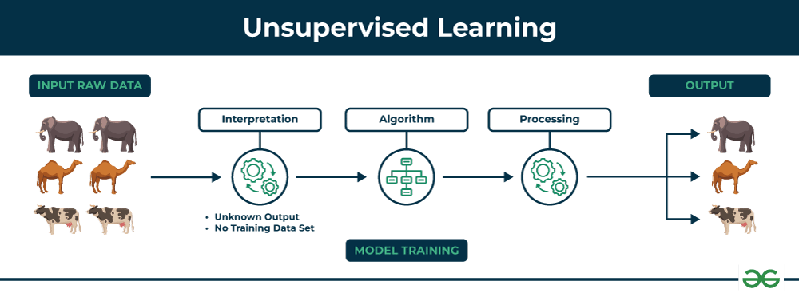
Example to understand
Imagine we have a machine learning model trained on many unlabeled images of dogs and cats. The model has never seen any labeled example that says “dog” or “cat” before so it doesn’t know how these animals look like.
Now, if we give the model a new image that contains both dogs and cats it won’t be able to directly label them as “dog” or “cat.” It will group parts of the image based on similarities and differences in features like shape or texture. It might separate the image into two groups one with dog-like features and other with cat-like features.
This happens because unsupervised learning doesn’t rely on prior knowledge or training with labeled data. It finds patterns and organizes data on its own helps in discovering information that wasn’t given before.
Types of Unsupervised Learning
Unsupervised learning is divided into two categories of algorithms:
1. Clustering
A clustering is used to group similar data points together. Clustering algorithms work by repeatedly moving data points closer to to the center of their group (cluster) and farther from points in other groups. This helps the algorithm to create clear and meaningful clusters. Some popular clustering algorithms include:
- K-means clustering
- Hierarchical clustering
- Principal Component Analysis (PCA)
- Singular Value Decomposition (SVD)
- Independent Component Analysis
- Gaussian Mixture Models (GMMs)
- Density-Based Spatial Clustering of Applications with Noise (DBSCAN)
2. Association rule learning
An association rule learning used to find patterns and relationships between different items in a dataset. It looks for rules like “people who buy X often also buy Y”.
Some common Association rule learning algorithms include:
- Apriori Algorithm
- Eclat Algorithm
- FP-Growth Algorithm
Application of Unsupervised learning
Unsupervised learning can be used to solve a variety of problems which includes:
- Anomaly detection: It can identify unusual patterns or behaviors in data helps in the detection of fraud, security breaches or system problems.
- Scientific discovery: It can show hidden relationships and patterns in scientific data which leads to new insights and ideas.
- Recommendation systems: It finds similarities in user behavior and preferences to recommend products, movies or music that align with their interests.
- Customer segmentation: It can identify groups of customers with similar characteristics which allows businesses to target marketing campaigns and improve customer service more effectively.
Advantages of Unsupervised learning
- It doesn’t need labeled data so we can start working with large datasets more easily and quickly.
- This handles large amounts of data and reduce it into simpler forms without losing important patterns which makes it manageable and efficient.
- It discovers patterns and relationships in the data that were previously unknown which offers valuable insights.
- By analyzing unlabeled data, it shows meaningful trends and groups that help us to understand our data deeply.
Disadvantages of Unsupervised learning
- Without labeled answers, it’s difficult to tell how accurate or effective the model is.
- Lack of clear guidance can lead to less precise results for complex problems.
- After grouping the data, we may needs to check and label these groupings which can be time-consuming.
- Missing data, outliers or noise in the data can easily affect the quality of the results.

2. Autoencoders in Machine Learning
Autoencoders are a special type of neural networks that learn to compress data into a compact form and then reconstruct it to closely match the original input. They consist of an:
- Encoder that captures important features by reducing dimensionality.
- Decoder that rebuilds the data from this compressed representation.
The model trains by minimizing reconstruction error using loss functions like Mean Squared Error or Binary Cross-Entropy. These are applied in tasks such as noise removal, error detection and feature extraction where capturing efficient data representations is important.

Architecture of Autoencoder
An autoencoder’s architecture consists of three main components that work together to compress and then reconstruct data which are as follows:
Autoencoder
1. Encoder
It compress the input data into a smaller, more manageable form by reducing its dimensionality while preserving important information. It has three layers which are:
- Input Layer: This is where the original data enters the network. It can be images, text features or any other structured data.
- Hidden Layers: These layers perform a series of transformations on the input data. Each hidden layer applies weights and activation functions to capture important patterns, progressively reducing the data's size and complexity.
- Output(Latent Space): The encoder outputs a compressed vector known as the latent representation or encoding. This vector captures the important features of the input data in a condensed form helps in filtering out noise and redundancies.
2. Bottleneck (Latent Space)
It is the smallest layer of the network which represents the most compressed version of the input data. It serves as the information bottleneck which force the network to prioritize the most significant features. This compact representation helps the model learn the underlying structure and key patterns of the input helps in enabling better generalization and efficient data encoding.
3. Decoder
It is responsible for taking the compressed representation from the latent space and reconstructing it back into the original data form.
- Hidden Layers: These layers progressively expand the latent vector back into a higher-dimensional space. Through successive transformations decoder attempts to restore the original data shape and details
- Output Layer: The final layer produces the reconstructed output which aims to closely resemble the original input. The quality of reconstruction depends on how well the encoder-decoder pair can minimize the difference between the input and output during training.
Loss Function in Autoencoder Training
During training an autoencoder’s goal is to minimize the reconstruction loss which measures how different the reconstructed output is from the original input. The choice of loss function depends on the type of data being processed:
- Mean Squared Error (MSE): This is commonly used for continuous data. It measures the average squared differences between the input and the reconstructed data.
- Binary Cross-Entropy: Used for binary data (0 or 1 values). It calculates the difference in probability between the original and reconstructed output.
During training the network updates its weights using backpropagation to minimize this reconstruction loss. By doing this it learns to extract and retain the most important features of the input data which are encoded in the latent space.
Efficient Representations in Autoencoders
Constraining an autoencoder helps it learn meaningful and compact features from the input data which leads to more efficient representations. After training only the encoder part is used to encode similar data for future tasks. Various techniques are used to achieve this are as follows:
- Keep Small Hidden Layers: Limiting the size of each hidden layer forces the network to focus on the most important features. Smaller layers reduce redundancy and allows efficient encoding.
- Regularization: Techniques like L1 or L2 regularization add penalty terms to the loss function. This prevents overfitting by removing excessively large weights which helps in ensuring the model to learns general and useful representations.
- Denoising: In denoising autoencoders random noise is added to the input during training. It learns to remove this noise during reconstruction which helps it focus on core, noise-free features and helps in improving robustness.
- Tuning the Activation Functions: Adjusting activation functions can promote sparsity by activating only a few neurons at a time. This sparsity reduces model complexity and forces the network to capture only the most relevant features.
Types of Autoencoders
Lets see different types of Autoencoders which are designed for specific tasks with unique features:
1. Denoising Autoencoder
Denoising Autoencoder is trained to handle corrupted or noisy inputs, it learns to remove noise and helps in reconstructing clean data. It prevent the network from simply memorizing the input and encourages learning the core features.
2. Sparse Autoencoder
Sparse Autoencoder contains more hidden units than input features but only allows a few neurons to be active simultaneously. This sparsity is controlled by zeroing some hidden units, adjusting activation functions or adding a sparsity penalty to the loss function.
3. Variational Autoencoder
Variational autoencoder (VAE) makes assumptions about the probability distribution of the data and tries to learn a better approximation of it. It uses stochastic gradient descent to optimize and learn the distribution of latent variables. They used for generating new data such as creating realistic images or text.
It assumes that the data is generated by a Directed Graphical Model and tries to learn an approximation to $q_{ϕ}(z∣x)$ to the conditional property $q_{θ}(z∣x)$ where $ϕ$and $θ$are the parameters of the encoder and the decoder respectively.
4. Convolutional Autoencoder
Convolutional autoencoder uses convolutional neural networks (CNNs) which are designed for processing images. The encoder extracts features using convolutional layers and the decoder reconstructs the image through deconvolution also called as upsampling.

3. Analyze and write short notes on the following. i. Vectors. (6marks) ii. Matrices. (7marks)
✅ i) Vectors (6 Marks – Detailed Explanation)
🔹 Definition
A vector is a one-dimensional ordered collection of numbers that represents magnitude and direction.
It is denoted as:
$$v=(v_{1},v_{2},v_{3},...,v_{n})$$

🔹 Geometric Interpretation
In 2D or 3D space, a vector is represented as an arrow from origin to a point.
The length of arrow = magnitude
The angle = direction

🔹 Types of Vectors
- Row Vector: $\left[1 2 3\right]$
- Column Vector:
$$\left[\begin{aligned}1 \\ 2 \\ 3\end{aligned}\right]$$
- Zero Vector: All elements are zero
- Unit Vector: Magnitude = 1

🔹 Important Operations
1️⃣ Vector Addition
$$u+v=(u_{1}+v_{1},u_{2}+v_{2})$$
2️⃣ Scalar Multiplication
$$av=(av_{1},av_{2})$$
3️⃣ Dot Product
$$u⋅v=∑u_{i}v_{i}$$
Measures similarity between vectors.
4️⃣ Magnitude (Norm)
$$∣∣v∣∣=\sqrt{v_{1}^{2}+v_{2}^{2}}$$

🔹 Applications in ML/DL
- Feature vectors represent input data
- Weight vectors represent model parameters
- Gradient vectors used in optimization

🔹 Conclusion
Vectors are fundamental for representing data, parameters, and directions in machine learning algorithms.

✅ ii) Matrices (7 Marks – Detailed Explanation)
🔹 Definition
A matrix is a two-dimensional rectangular array of numbers arranged in rows and columns.
$$A=\left[\begin{matrix}a_{11} & a_{12} \\ a_{21} & a_{22}\end{matrix}\right]$$
Order = m × n (rows × columns)

🔹 Types of Matrices
- Row Matrix (1 × n)
- Column Matrix (m × 1)
- Square Matrix (n × n)
- Identity Matrix (I)
- Zero Matrix
- Diagonal Matrix

🔹 Important Operations
1️⃣ Matrix Addition
Same order matrices only.
2️⃣ Matrix Multiplication
If A is (m × n) and B is (n × p),
Result is (m × p).
3️⃣ Transpose
$$A^{T}$$
Rows become columns.
4️⃣ Determinant
$$∣A∣$$
Used to check invertibility.
5️⃣ Inverse
$$A^{-1}$$
Exists only if determinant ≠ 0.

🔹 Role in Deep Learning
- Dataset stored as matrix (samples × features)
- Weight matrices connect neural layers
- Forward propagation:
$$Z=WX+b$$
- Efficient GPU computation via matrix operations

🔹 Conclusion
Matrices enable large-scale computations, transformations, and are the backbone of neural network calculations.

4,Assess the following. i. Expectation .(5) ii. Variance.(4) iii. Covariance. (4)
✅ i) Expectation (5 Marks – Detailed Explanation)

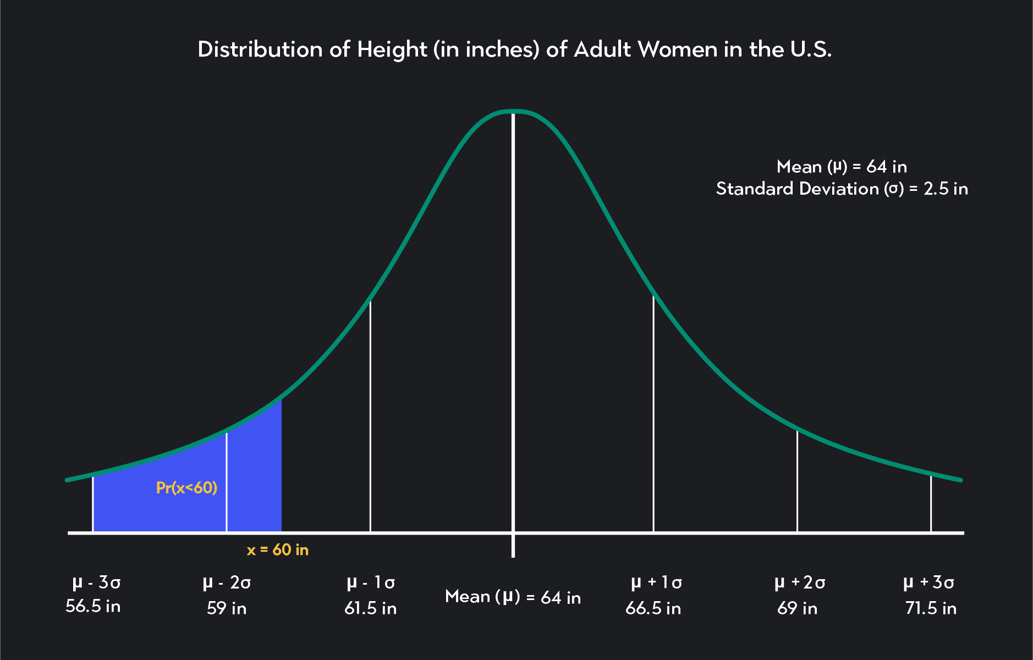
🔹 Definition
Expectation (Expected Value) is the theoretical average of a random variable over repeated trials.
It represents the long-run average outcome of a random experiment.

🔹 Mathematical Formulation
➤ Discrete Random Variable
$$E(X)=\sum_{i}{x_{i}}P(x_{i})$$
➤ Continuous Random Variable
$$E(X)=\int_{-∞}^{∞}{xf(x) dx}$$
Where:
- $P(x_{i})$= probability mass function
- $f(x)$= probability density function

🔹 Interpretation
- It is a weighted average of all possible values.
- May not be an actual observed value (e.g., dice → 3.5).

🔹 Properties
- Linearity:
$$E(aX+bY)=aE(X)+bE(Y)$$
- $E(c)=c$(constant)
- Independent or not, linearity always holds.

🔹 Applications in ML
- Used in defining loss functions
- Used in risk minimization
- Forms basis for variance and covariance
- Used in probabilistic deep learning models

✅ ii) Variance (4 Marks – Detailed Explanation)

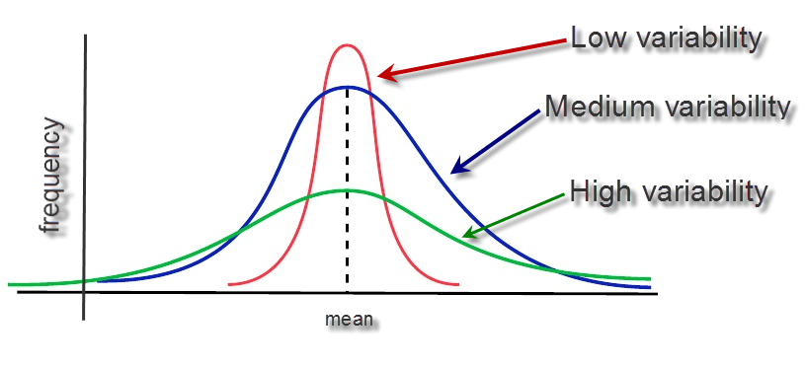

🔹 Definition
Variance measures the dispersion of data around the mean.
It quantifies uncertainty in a random variable.

🔹 Formula
$$Var(X)=E[(X-μ)^{2}]$$
Alternative form:
$$Var(X)=E(X^{2})-[E(X)]^{2}$$
Where $μ=E(X)$

🔹 Interpretation
- High variance → Data widely spread
- Low variance → Data concentrated near mean
- Always non-negative

🔹 Properties
- $Var(c)=0$
- $Var(aX)=a^{2}Var(X)$

🔹 Importance in Deep Learning
- Explains bias–variance tradeoff
- High variance → Overfitting
- Used in weight initialization and model evaluation

✅ iii) Covariance (4 Marks – Detailed Explanation)
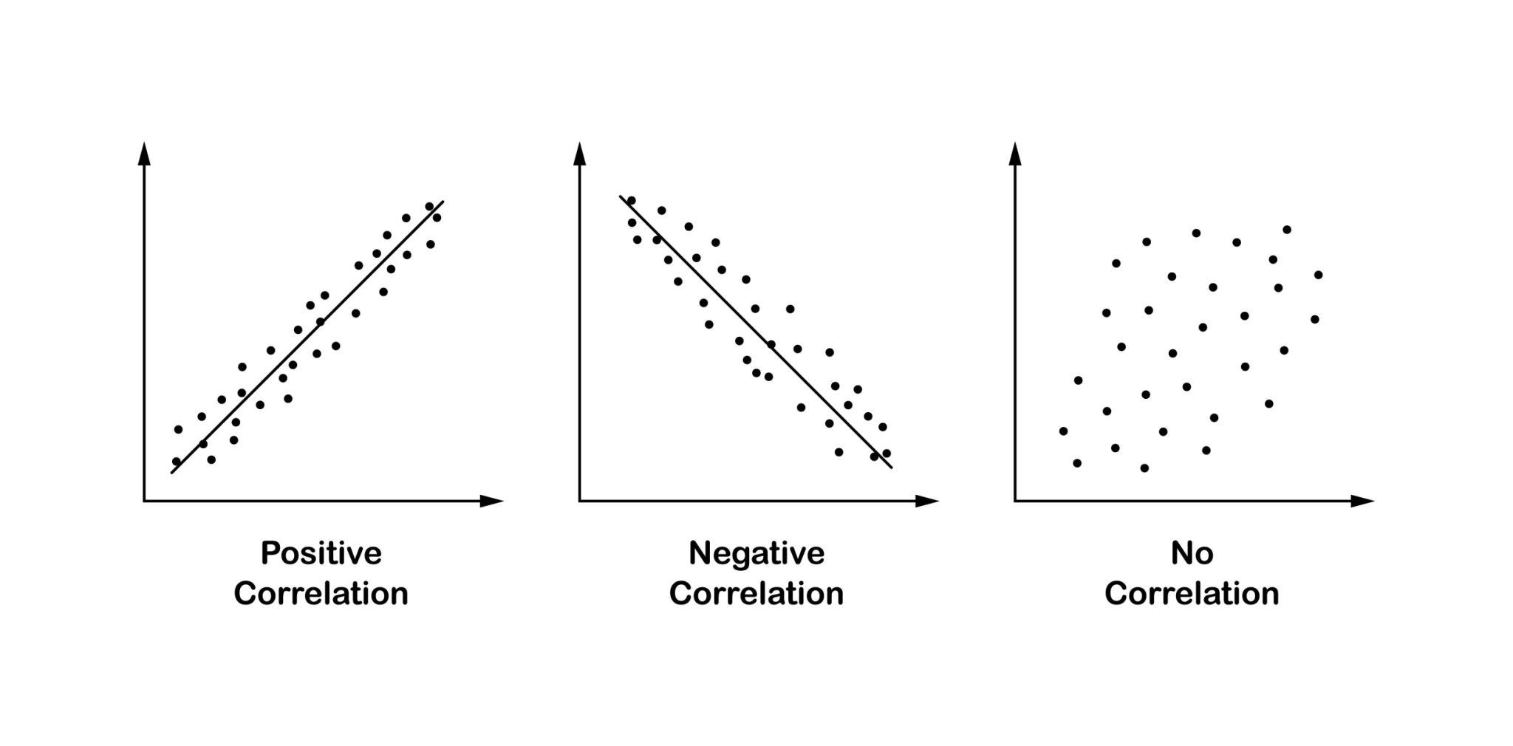
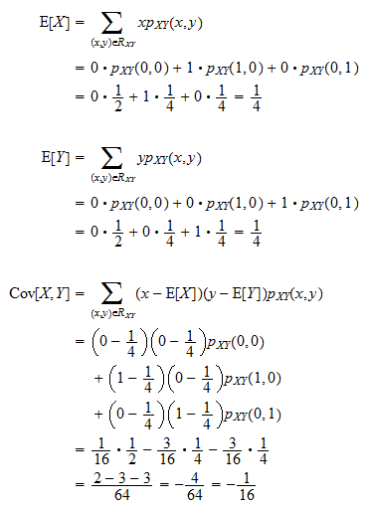

4
🔹 Definition
Covariance measures how two random variables change together.

🔹 Formula
$$Cov(X,Y)=E[(X-μ_{X})(Y-μ_{Y})]$$
Alternative form:
$$Cov(X,Y)=E(XY)-E(X)E(Y)$$

🔹 Interpretation
- Positive covariance → Both increase together
- Negative covariance → One increases, other decreases
- Zero → No linear relationship

🔹 Special Case
$$Var(X)=Cov(X,X)$$

🔹 Applications in ML
- Used in Covariance Matrix
- Important in PCA (Principal Component Analysis)
- Measures feature relationships in datasets

✅ Final Assessment Summary
- Expectation gives average behavior of random variable.
- Variance measures spread or uncertainty.
- Covariance measures relationship between variables.
Together, they form the foundation of probability theory and deep learning mathematics.

5. Explain the following in detail. i. Eigen Decomposition. (7) ii. Tensors. (6)
i) Eigen Decomposition (7 Marks)
Introduction
Eigen Decomposition is a matrix factorization technique where a square matrix is broken into eigenvalues and eigenvectors.
It is widely used in machine learning, deep learning, PCA, and data analysis.

Basic Concept
For a square matrix A, if there exists a vector v such that:
$$Av=λv$$
Then:
- v → Eigenvector
- λ (lambda) → Eigenvalue
Meaning:
When matrix A multiplies vector v, the direction of v does not change — only its magnitude changes.

Eigen Decomposition Formula
If matrix A has n eigenvectors, then:
$$A=VΛV^{-1}$$
Where:
- V = matrix of eigenvectors
- Λ = diagonal matrix of eigenvalues
- V⁻¹ = inverse of eigenvector matrix

Example (Simple)
Let:
$$A=\left[\begin{matrix}2 & 0 \\ 0 & 3\end{matrix}\right]$$
Eigenvalues:
$$λ_{1}=2,λ_{2}=3$$
Eigenvectors:
$$v_{1}=[1,0],v_{2}=[0,1]$$
This matrix only scales axes, not rotate.

Applications in Deep Learning / ML
- Principal Component Analysis (PCA)
- Dimensionality Reduction
- Covariance matrix analysis
- Feature extraction
- Stability analysis

Advantages
- Helps understand matrix transformation
- Useful in data compression
- Reduces dimensionality
- Improves learning efficiency

Limitations
- Works only for square matrices
- Requires matrix to have enough eigenvectors

ii) Tensors (6 Marks)
Introduction
A Tensor is a generalization of scalars, vectors, and matrices to higher dimensions.
It is the basic data structure in deep learning frameworks like TensorFlow and PyTorch.

Tensor by Dimension
Type | Dimension | Example
Scalar | 0D | 5
Vector | 1D | [1, 2, 3]
Matrix | 2D | 2×2 table
Tensor | 3D+ | Image, Video

Example of Tensor
1D Tensor (Vector)
$$\left[2 , 4 , 6\right]$$
2D Tensor (Matrix)
$$\left[\begin{matrix}1 & 2 \\ 3 & 4\end{matrix}\right]$$
3D Tensor (Image)
Height × Width × Channels
Example:
RGB Image = (224 × 224 × 3)

Tensors in Deep Learning
Tensors store:
- Input data
- Weights
- Activations
- Gradients
Example:
- Image → 3D tensor
- Batch of images → 4D tensor
- Video → 5D tensor

Operations on Tensors
- Addition
- Multiplication
- Dot product
- Convolution
- Reshaping

Applications
- Neural network computations
- Image processing (CNN)
- NLP embeddings
- Scientific computing

Advantages
- Handles multi-dimensional data
- Efficient computation on GPU
- Core structure in deep learning

Part – c
6.Assess the historical developments in deep learning. for 15 marks

Assess the Historical Developments in Deep Learning

1. Introduction
Deep Learning is a subfield of Machine Learning that focuses on artificial neural networks with multiple hidden layers.
Its development spans over seven decades, evolving from simple perceptrons to powerful deep neural networks used in AI systems today.
The progress of deep learning can be divided into major historical phases.

2. Early Foundations (1940s–1960s)
2.1 McCulloch-Pitts Neuron (1943)
- Proposed by Warren McCulloch and Walter Pitts.
- First mathematical model of an artificial neuron.
- Introduced binary threshold logic.
Model:
$$y=\left\{\begin{matrix}1 & \text{if }∑w_{i}x_{i}≥θ \\ 0 & \text{otherwise}\end{matrix}\right.$$
👉 Laid the foundation for neural networks.

2.2 Perceptron (1958)
Developed by Frank Rosenblatt.
- Single-layer neural network.
- Used for binary classification.
- Could only solve linearly separable problems.
Limitation:
- Could not solve XOR problem.
This limitation slowed research in neural networks.

3. First AI Winter (1970s–1980s)
- Marvin Minsky and Seymour Papert proved perceptrons cannot solve non-linear problems.
- Funding reduced.
- Neural network research declined.
However, during this time:
- Development of multi-layer neural networks began.
- Concept of hidden layers introduced.

4. Backpropagation Revival (1986)
David Rumelhart, Geoffrey Hinton, and Ronald Williams reintroduced Backpropagation algorithm.
Backpropagation allowed:
- Training of multi-layer neural networks.
- Efficient weight updates using gradient descent.
Weight update rule:
$$w=w-η\frac{∂L}{∂w}$$
This was a major breakthrough.

5. Second AI Winter (1990s)
Despite backpropagation:
- Limited computational power
- Small datasets
- Overfitting problems
Other ML techniques (SVM, decision trees) became more popular.
Deep learning research again slowed.

6. Modern Deep Learning Revolution (2006–Present)
6.1 Deep Belief Networks (2006)
Geoffrey Hinton introduced unsupervised pre-training using Deep Belief Networks (DBNs).
This solved:
- Vanishing gradient problem
- Poor initialization
Marked the beginning of modern deep learning.

6.2 ImageNet Breakthrough (2012)
In 2012, Alex Krizhevsky, Ilya Sutskever, and Geoffrey Hinton developed AlexNet.
- Won ImageNet competition.
- Reduced error rate significantly.
- Used GPUs for training.
- Popularized Convolutional Neural Networks (CNNs).
This event triggered deep learning explosion.

7. Advancements After 2012
7.1 Convolutional Neural Networks (CNNs)
Used for:
- Image recognition
- Object detection
- Medical imaging
7.2 Recurrent Neural Networks (RNNs) & LSTMs
Used for:
- Speech recognition
- Language modeling
- Time series prediction
7.3 Transformers (2017)
Introduced in the paper:
"Attention Is All You Need"
Revolutionized:
- Natural Language Processing
- Large Language Models (LLMs)

8. Key Factors Behind Deep Learning Success
- Availability of large datasets (Big Data)
- High computational power (GPUs, TPUs)
- Improved algorithms (ReLU, Adam optimizer)
- Better regularization methods (Dropout, Batch Normalization)

9. Critical Assessment
Strengths of Historical Development
- Continuous theoretical improvement
- Overcame early limitations (XOR, vanishing gradients)
- Scaled with hardware improvements
- Achieved human-level performance in many tasks
Challenges Faced
- AI winters due to overhyped expectations
- Computational cost
- Interpretability issues
- Data dependency

10. Conclusion
The historical development of deep learning shows a cycle of:
- Innovation
- Limitation
- Decline
- Revival
From the McCulloch-Pitts neuron to modern transformer-based architectures, deep learning has evolved into the backbone of modern Artificial Intelligence.
Today, it powers applications such as:
- Self-driving cars
- Medical diagnosis
- Speech assistants
- Large language models
Thus, deep learning has transformed from a theoretical concept into a revolutionary technology shaping the future of AI.

Unit – 2
1.Justify the application of Dataset Augmentation various tasks (13)
Justify the Application of Dataset Augmentation in Various Tasks
Introduction
Dataset Augmentation is the process of artificially expanding the training dataset by applying label-preserving transformations such as rotation, flipping, scaling, cropping, noise addition, and data synthesis. It helps deep learning models learn robust, invariant, and generalized features without collecting new real-world data.
In modern deep learning, dataset augmentation is considered a core technique to improve performance, reduce overfitting, and handle data scarcity.

Why Dataset Augmentation is Needed
Real-world datasets often suffer from:
- Limited labeled data
- High data collection cost
- Class imbalance
- Overfitting in deep networks
- Sensitivity to noise and variations
Dataset augmentation generates diverse training samples and helps the model learn real-world variability.

Applications of Dataset Augmentation in Various Tasks
1. Image Classification
Augmentation techniques:
- Rotation, flipping, cropping, zooming, brightness/contrast change
Justification
Objects in real life appear in different orientations, sizes, and lighting conditions. Augmentation helps the model become invariant to such variations.
Example
A handwritten digit "6" rotated slightly is still "6".
In CIFAR-10 dataset, flipping an image of a dog still represents a dog → improves classification accuracy.

2. Object Detection
Augmentation techniques:
- Random cropping
- Scaling
- Translation
- Horizontal flipping
- Mosaic augmentation (YOLO)
Justification
Objects may appear:
- At different locations
- In different sizes
- Partially visible
Augmentation helps the detector learn scale and position invariance.
Example
In self-driving cars, pedestrians appear at different distances → scaling augmentation helps detect both near and far pedestrians.

3. Image Segmentation
Augmentation techniques:
- Elastic deformation
- Rotation and mirroring
- Noise addition
Justification
Segmentation requires precise boundary detection. Augmentation helps model learn shape variation and improves segmentation quality.
Example
In medical imaging, tumor shapes vary → elastic deformation improves segmentation of irregular tumor boundaries.

4. Medical Imaging
Medical datasets are usually small and expensive.
Augmentation techniques:
- Rotation
- Noise addition
- Intensity scaling
- Contrast adjustment
Justification
Improves robustness to:
- Scanner noise
- Patient movement
- Different imaging devices
Example
In MRI brain tumor classification, rotated MRI scans still represent the same tumor → improves diagnostic accuracy.

5. Speech Recognition
Augmentation techniques:
- Add background noise
- Pitch shifting
- Time stretching
- Reverberation
Justification
Real-world audio contains noise and environmental variations. Augmentation makes the model noise-robust.
Example
Speech model trained with noisy audio can recognize voice commands even in traffic noise or crowded places.

6. Natural Language Processing (NLP)
Augmentation techniques:
- Synonym replacement
- Sentence paraphrasing
- Back translation
- Random insertion/deletion
Justification
Text data may be limited. Augmentation increases linguistic diversity and improves semantic understanding.
Example
Original: "The movie is good"
Augmented: "The film is nice" → same meaning → improves sentiment classifier.

7. Time Series Forecasting
Augmentation techniques:
- Noise injection
- Time warping
- Window slicing
- Scaling
Justification
Helps model learn temporal variation and improves prediction stability.
Example
In stock prediction, slight noise in historical data makes the model robust to market fluctuations.

8. Handling Class Imbalance
In many datasets, some classes have fewer samples.
Justification
Augmenting minority class:
- Prevents model bias
- Improves recall and F1-score
- Balances dataset
Example
In fraud detection, fraudulent transactions are rare → augment fraud samples → improves fraud detection.

9. Improves Generalization
Augmentation exposes the model to multiple variations → model learns general patterns instead of memorizing training data.
Example
Face recognition trained with rotated and brightness-varied images works well in real-world lighting and angles.

10. Reduces Overfitting
Augmentation increases dataset diversity → prevents model from memorizing training data → reduces training-validation gap.
Example
CNN trained on small dataset without augmentation → 99% training accuracy, 70% validation accuracy (overfitting)
With augmentation → validation accuracy improves.

11. Improves Robustness to Noise
Noise injection during training helps the model ignore irrelevant variations.
Example
Image classifier trained with noisy images can still classify blurred or slightly distorted images correctly.

12. Cost and Time Efficient
Collecting real data:
- Expensive
- Time consuming
- Sometimes impossible
Augmentation generates large dataset cheaply and quickly.

13. Improves Deep Network Stability
Deep networks require large data. Augmentation:
- Prevents gradient instability
- Improves convergence
- Enhances feature learning

Advanced Augmentation Techniques
- GAN-based augmentation → Generate synthetic data
- Mixup → Combine two images
- CutMix → Patch mixing
- AutoAugment → Automated augmentation selection
Example
GAN generates synthetic medical images to improve disease detection when real data is limited.

2. Explain output units of feed forward networks. (13)
Explain Output Units of Feed Forward Networks
Introduction
In a Feed Forward Neural Network (FFNN), the output unit (output layer) produces the final prediction of the model. The type of output unit depends on the nature of the problem such as regression, binary classification, multi-class classification, or structured prediction.
Choosing the correct output unit is important because it determines:
- How predictions are represented
- Which loss function is used
- How the network learns

Types of Output Units in Feed Forward Networks
1. Linear Output Units (For Regression)
Definition:
Linear output units produce real-valued outputs without applying any non-linear activation.
$$y=Wx+b$$
Used for:
- Regression problems
- Predicting continuous values
Examples:
- House price prediction → output = ₹5,00,000
- Temperature prediction → output = 32.5°C
- Stock price prediction
Loss function used: Mean Squared Error (MSE)
Justification:
Since regression requires continuous output, linear units are suitable.

2. Sigmoid Output Units (For Binary Classification)
Definition:
Sigmoid squashes output between 0 and 1, representing probability.
$$y=\frac{1}{1+e^{-z}}$$
Used for:
Binary classification problems
Output meaning:
- Output close to 1 → Class 1
- Output close to 0 → Class 0
Examples:
- Spam detection (Spam / Not Spam)
- Disease detection (Yes / No)
- Fraud detection
Loss function used: Binary Cross-Entropy
Justification:
Sigmoid outputs probability → suitable for binary decision.

3. Softmax Output Units (For Multi-class Classification)
Definition:
Softmax converts outputs into a probability distribution over multiple classes.
$$y_{i}=\frac{e^{z_{i}}}{∑e^{z_{j}}}$$
Property:
Sum of all output probabilities = 1
Used for:
Multi-class classification
Examples:
- Digit recognition (0–9)
- Object classification (Cat, Dog, Car)
- Emotion detection
Loss function used: Categorical Cross-Entropy
Justification:
Softmax selects the most probable class among many.

4. Tanh Output Units
Definition:
Produces output between −1 and +1
$$y=tanh(z)$$
Used for:
- When output must be centered around zero
- Some regression or signal-processing tasks
Example:
- Predicting normalized signals
- Control system outputs

5. ReLU Output Units (Rarely used in output layer)
Definition:
$$y=max(0,z)$$
Used for:
- Sometimes in regression where output cannot be negative
Example:
- Predicting number of people
- Predicting sales count

6. Probabilistic Output Units
Used when model must predict probability distributions.
Includes:
- Softmax
- Sigmoid
Example:
Predict probability of disease risk:
- Low risk = 0.2
- Medium = 0.5
- High = 0.3

Choosing the Correct Output Unit
Problem Type | Output Unit | Loss Function
Regression | Linear | MSE
Binary Classification | Sigmoid | Binary Cross Entropy
Multi-class Classification | Softmax | Categorical Cross Entropy
Multi-label Classification | Sigmoid (multiple units) | Binary Cross Entropy
Positive-only Regression | ReLU | MSE

Example of Output Units in Real Applications
Example 1: House Price Prediction
- Output Unit → Linear
- Output → ₹6,20,000
Example 2: Email Spam Detection
- Output Unit → Sigmoid
- Output → 0.92 (Spam)
Example 3: Handwritten Digit Recognition
- Output Unit → Softmax (10 neurons)
- Output → Digit "5" with highest probability

Importance of Output Units
- Controls prediction format
- Affects learning behavior
- Determines suitable loss function
- Influences model performance
Wrong output unit → poor training and wrong predictions.

Conclusion
Output units in Feed Forward Networks play a crucial role in producing the final prediction. Different output units such as Linear, Sigmoid, and Softmax are used based on the problem type like regression, binary classification, and multi-class classification. Choosing the correct output unit ensures proper learning, accurate predictions, and efficient model performance.

3. i. Develop Back Propagation algorithm. (7) ii. List the regularization steps for deep learning. (6)
i) Back Propagation Algorithm (Easy Explanation with Example) — (7 Marks)
What is Backpropagation?
Backpropagation is the main training method used in feed-forward neural networks.
It reduces prediction error by sending error backward and updating weights.
Idea:
Forward → Calculate Error → Send Error Back → Adjust Weights → Repeat

Steps of Backpropagation (Simple)
Step 1: Initialize Weights
- Assign small random values to weights and bias.
- Choose learning rate (η), e.g., 0.01.

Step 2: Forward Pass
- Input is passed through network.
- Hidden layer calculates output.
- Output layer produces prediction (ŷ).
Example:
Input = (Study hours = 4)
Network predicts = 60 marks

Step 3: Calculate Error
Compare predicted output with actual output.
Error = Actual − Predicted
Example:
Actual marks = 80
Predicted = 60
Error = 20
If error is high → weights must be adjusted.

Step 4: Backward Pass (Error Backpropagation)
Error is sent backward from output → hidden layer.
Network calculates:
- Which weights caused more error?
- How much to change each weight?
This uses chain rule of derivatives.

Step 5: Update Weights
Weights are adjusted to reduce error.
Formula (simple):
New Weight = Old Weight + (Learning Rate × Error × Input)
Example:
Old weight = 0.5
Learning rate = 0.1
Error = 20
New weight = 0.5 + (0.1 × 20) = 2.5
Now prediction improves.

Step 6: Repeat Until Error is Small
Network repeats:
- Forward pass
- Error calculation
- Backward pass
- Weight update
Until:
- Error becomes very small OR
- Maximum epochs reached

Real-Life Example
Example: Spam Email Detection
- Input → Email features
- Output → Spam (1) / Not Spam (0)
Initially model predicts wrong → error occurs → backprop updates weights → model becomes accurate.

Key Points to Write
- Backpropagation trains neural networks
- Uses forward + backward process
- Uses gradient descent
- Uses chain rule
- Updates weights automatically
- Reduces error step by step

ii) Regularization Steps for Deep Learning (Easy with Examples) — (6 Marks)
What is Regularization?
Regularization is used to prevent overfitting.
Overfitting: Model memorizes training data but performs poorly on new data.
Regularization makes the model generalize better.

Regularization Steps (Simple)
Step 1: Add Penalty to Loss Function
Modify loss:
Loss = Original Loss + λ × Penalty
Controls large weights.

Step 2: L2 Regularization (Weight Decay)
- Reduces large weight values
- Makes model stable
Example:
Without L2 → weights become very large → overfitting
With L2 → weights stay small → better generalization

Step 3: L1 Regularization
- Makes some weights exactly zero
- Removes unnecessary features
Example:
In house price prediction, useless features like “wall color” get removed.

Step 4: Dropout
- Randomly turns OFF some neurons during training
- Forces network to learn independently
Example:
If some neurons fail → model still works → improves robustness

Step 5: Data Augmentation
Increase training data using:
- Rotation
- Flip
- Noise
- Scaling
Example:
Cat image rotated → still cat → improves classification accuracy
Used in:
- Image classification
- Medical imaging
- Object detection

Step 6: Early Stopping
- Monitor validation error
- Stop training when validation error increases
Prevents over-training.
Example:
Training accuracy ↑ but validation accuracy ↓ → stop training → avoid overfitting
Other Regularization Methods (Extra Points)
- Noise Injection → add noise during training
- Batch Normalization → stabilizes learning
- Ensemble Learning → combine multiple models
Real-Life Example of Regularization
Example: Face Recognition
Without regularization:
- Model memorizes training faces → fails on new faces
With regularization:
- Model learns general features → works on new faces
Easy List to Remember
- L1 Regularization
- L2 Regularization
- Dropout
- Data Augmentation
- Early Stopping
- Noise Injection
4. Explain in detail about chain rule of calculus. (13)
Chain Rule of Calculus in Deep Learning (Simple Explanation)
Introduction
The Chain Rule is used to find the derivative of a function made of many small functions connected together.
In deep learning, neural networks have many layers, so the loss depends on many intermediate values.
The chain rule helps us calculate how the loss changes with respect to each weight, which is required for Backpropagation.

Basic Idea of Chain Rule
If:
- y depends on u
- u depends on x
Then:
$$\frac{dy}{dx}=\frac{dy}{du}×\frac{du}{dx}$$
Meaning:
Change in outer function × Change in inner function

Why Chain Rule is Important in Deep Learning
In neural network:
- Loss depends on Output
- Output depends on Activation
- Activation depends on Weights
So we must find:
$$\frac{dLoss}{dWeight}$$
Using chain rule:
$$\frac{dL}{dW}=\frac{dL}{dOutput}×\frac{dOutput}{dActivation}×\frac{dActivation}{dWeight}$$
This allows error to move backward through layers.
Without chain rule → No gradient → No learning.

Simple Neural Network Example
Consider one neuron:
$$Z=WX+b \\ Y=f(Z) \\ L=(Y-T)^{2}$$
Where:
- X = input
- W = weight
- Y = output
- T = target
- L = loss
We want to know: How loss changes when weight changes?

Step-by-Step Using Chain Rule (Simple)
Step 1: Loss w.r.t Output
$$\frac{dL}{dY}=2(Y-T)$$
(Error term)

Step 2: Output w.r.t Z
If sigmoid activation:
$$\frac{dY}{dZ}=Y(1-Y)$$

Step 3: Z w.r.t Weight
$$\frac{dZ}{dW}=X$$

Step 4: Apply Chain Rule
$$\frac{dL}{dW}=\frac{dL}{dY}×\frac{dY}{dZ}×\frac{dZ}{dW} \\ =2(Y-T)×Y(1-Y)×X$$
This value tells how much to change weight.

Chain Rule in Backpropagation
Backpropagation uses chain rule to send error from output layer → hidden layer → input layer.
For each layer:
$$Gradient=Error×Input$$
Chain rule connects all layers so the network can learn.

Real-Life Example
Example: Exam Marks Prediction
- Input → Study hours
- Output → Predicted marks
- Loss → Difference between actual & predicted marks
Chain rule helps find:
If weight changes slightly, how much will marks prediction change?
So weights get updated → prediction improves.

Advantages
- Helps compute gradient
- Makes backpropagation possible
- Works for multi-layer neural networks
- Enables training of deep learning models

Problems Related to Chain Rule
- In deep networks, gradients may become very small → Vanishing Gradient
- Or very large → Exploding Gradient

Applications in Deep Learning
- Backpropagation
- Gradient Descent
- CNN, RNN, Deep Networks
- Automatic differentiation (TensorFlow, PyTorch)

Conclusion
The Chain Rule is the core mathematical tool used in deep learning to compute gradients through multiple layers. It helps propagate error backward and update weights during backpropagation. Without the chain rule, neural networks cannot learn or optimize.

